Travis Erwin
CS370
Mohammad Habibi
10/17/2026

Design Defense

Analyze the differences between human and machine approaches to solving problems.
- Describe the steps a human being would take to solve this maze.
The human approach to solving the pirate treasure maze the way it is designed in this project would be to view the maze as it is shown in its entirety, identify which spaces you can move to and which spaces are walls, then navigate through the open spaces to the treasure.
Humans would use visual observation and reasoning to identify a path to the treasure in the simplified 8x8 version solving the puzzle quickly. If the puzzle were to get larger and more complex, it would require an added element of exploration as well as trial and error.
- Describe the steps your intelligent agent is taking to solve this pathfinding problem.
The intelligent agent has a different approach. The agent uses deep Q-learning and reinforcement learning to determine which moves will lead to the treasure through trial and error. It is given possible moves that it can make (up, down, left, and right) which result in penalties and a reward. Finding the treasure rewards the agent with +1, moving to an open space results in a small penalty of -0.04, revisiting a previously explored space results in a penalty of -0.25, and an invalid move like running into a wall results in a penalty -0.75.
The agent stores these experiences and uses a neural network to learn which movements lead to the highest reward. As the training progresses, the agent uses less exploration and starts to exploit what it has learned to take a more efficient path to the treasure. During testing, I modified the algorithm to select only valid movements with the highest predicted Q-values, which ensured the agent did not attempt moves into walls or outside the maze. This significantly improved performance, allowing the agent to achieve a 100% win rate and pass the completion check much faster than earlier iterations.

- What are the similarities and differences between these two approaches?
Humans can observe the maze and recognize the best route to the treasure using logic and reasoning before making any movements. The intelligent agent uses reinforcement learning to determine which movements result in the highest numeric rewards. It stores previous experiences and uses them to learn how to find the treasure from randomized starting positions. While this can seem to emulate giving vision and reasoning to the agent, it is actually processing numerical representations of the maze and using past experiences, movement rules, and rewards to adjust the weights of its neural network. These weights help the agent predict which movements will produce the highest numeric reward and ultimately lead to the treasure.
While these approaches are quite different, they both have the similarity of using information about the maze and previous experience to make decisions about which path will lead to the maze.

Assess the purpose of the intelligent agent in pathfinding.
- What is the difference between exploitation and exploration? What is the ideal proportion of exploitation and exploration for this pathfinding problem? Explain your reasoning.
In reinforcement learning, exploitation is using past experiences to make decisions that are expected to result in the highest reward by using efficient decisions and risk aversion. Exploration is most prominent in the initial phase where the model selects actions with uncertain outcomes to gain information of potential states and rewards. As the agent gains experience, uncertainty is reduced, and the agent gradually shifts from exploration toward exploitation (GeeksforGeeks, 2025).
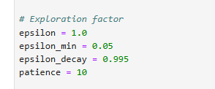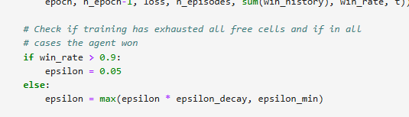
In this model, exploration starts at 100% and multiplied by .995 every epoch reducing exploration to a minimum of 5%. Once the win rate is above 90%, the exploration rate stays at 5%. The ideal balance of exploration vs exploitation changes as the model trains. In early epochs, exploration needs to be higher to gain experience and knowledge of the map. As training progresses, the exploration rate should gradually reduce, and the exploitation rate should grow. Once the win rate is over 90%, then the model becomes 95% exploitation and 5% exploration.
- How can reinforcement learning help to determine the path to the goal (the treasure) by the agent (the pirate)?
Reinforcement learning starts with the agent interacting with its environment taking actions and receiving rewards, learning through feedback and then implementing that feedback to maximize its cumulative rewards (Waseem, 2025).
In this pirate treasure maze, the agent begins by interacting with the map and exploring different paths to receive rewards and penalties. As the agent travels through the maze, it learns which movements result in the highest expected rewards and begins exploiting that knowledge to solve the maze efficiently. Through repeated training the agent learns to solve the maze at a 100% win rate from any starting position.

Evaluate the use of algorithms to solve complex problems.
- How did you implement deep Q-learning using neural networks for this game?
A DQN consists of two neural networks, the Q-network and the target network, along with an experience replay component. The process begins with the agent interacting with its environment, taking actions, and storing the resulting states and rewards in experience replay. Random batches of these experiences are then used to train the neural networks. The Q-network predicts Q-values for the actions taken, while the target network predicts target Q-values based on the resulting states. These values are compared to calculate the loss, which is used to adjust the weights of the Q-network. The target network remains unchanged during this process until the updated weights from the Q-network are periodically copied over to it (Doshi, 2020). 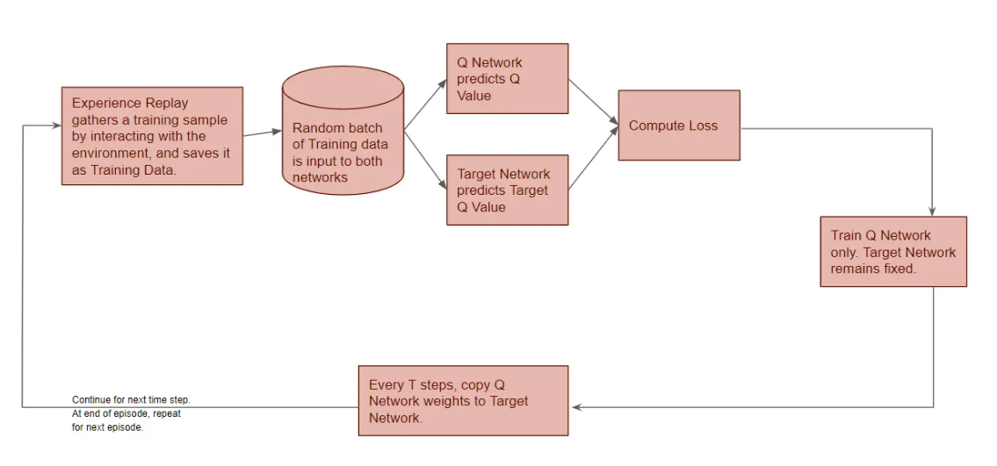
This is implemented into the pirate maze game by creating an experience replay component with a training loop that stores the agent’s experiences. 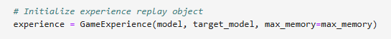 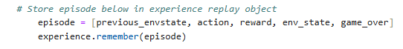
The Q-network uses a batch of training data retrieved from the experience replay component. The experience replay component prepares the inputs and target Q-values, which are then passed to the training function. The network's weights are adjusted to reduce the difference between predicted Q-values and target Q-values, and the loss is recorded to monitor training.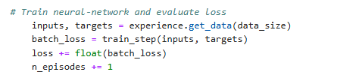
The target network is created by cloning the Q-network and copying its initial weights. Both networks are then passed to the GameExperience component, where the target network is used to calculate target Q-values for training. Unlike the Q-network, which continuously adjusts its weights during training, the target network maintains its weights between periodic updates to provide more stable training targets 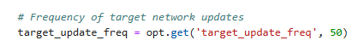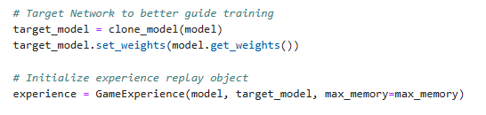
As I was testing, I noticed that the agent was selecting invalid movements, causing the model to go through 1,000 epochs without successfully completing the entire maze. This occurred because the agent was selecting movements strictly based on the highest predicted Q-values, regardless of whether those movements were valid. I modified the algorithm to select only valid movements, which increased the agent's efficiency. After implementing this change, the agent consistently achieved a 100% win rate and successfully passed the completion check at epoch 245 and 214 in two separate tests, well before the 1,000-epoch limit.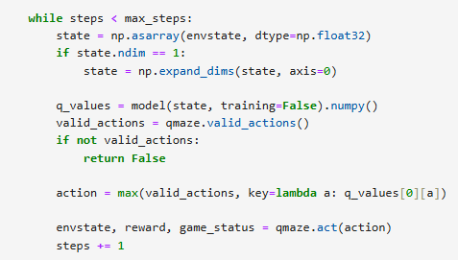 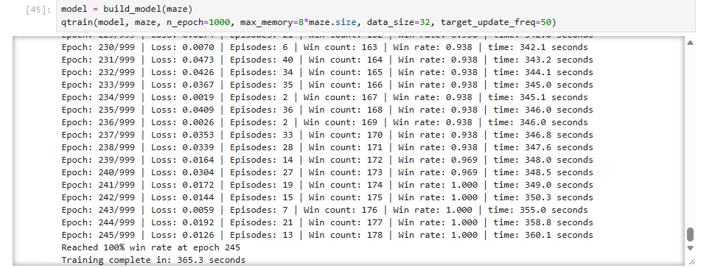
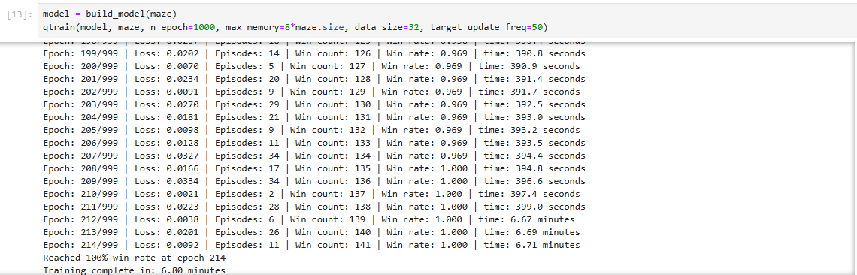

References:
GeeksforGeeks. (2025, July 23). Exploitation and exploration in machine learning. https://www.geeksforgeeks.org/machine-learning/exploitation-and-exploration-in-machine-learning/

Waseem, H. (2025, February 10). How does reinforcement learning work? Educative. https://www.educative.io/blog/how-does-reinforcement-learning-work

Doshi, K. (2020, December 19). Reinforcement learning explained visually (part 5): Deep Q networks, step-by-step. Medium. https://medium.com/data-science/reinforcement-learning-explained-visually-part-5-deep-q-networks-step-by-step-5a5317197f4b

